LAB EXPERIMENT RECORD-29/09/2026
Set 1: Monthly Sales Data

Department | AIML
Course Code / Course Name | DSA0601 / Data Handling and Visualization
Experiment | Data Visualization using R
Name | S.SIVA SAINATH REDDY
Register Number | 192325114
Date | 29 September 2026
Day | Tuesday

Aim
To visualize monthly sales data using a line chart, bar chart, and scatter plot, and to build an interactive dashboard using R and Shiny.

Dataset: Monthly Sales
Month | Sales ($)
January | 15000
February | 18000
March | 22000
April | 20000
May | 23000

PROGRAM 1: Line Chart of Monthly Sales
Create a line chart to visualize the monthly sales. Label the axes and title the chart appropriately.
# Dataset month <- c("January", "February", "March", "April", "May") sales <- c(15000, 18000, 22000, 20000, 23000)

# Line Chart plot(sales, type = "o", xaxt = "n", xlab = "Month", ylab = "Sales ($)", main = "Monthly Sales", col = "blue")

axis(1, at = 1:5, labels = month)

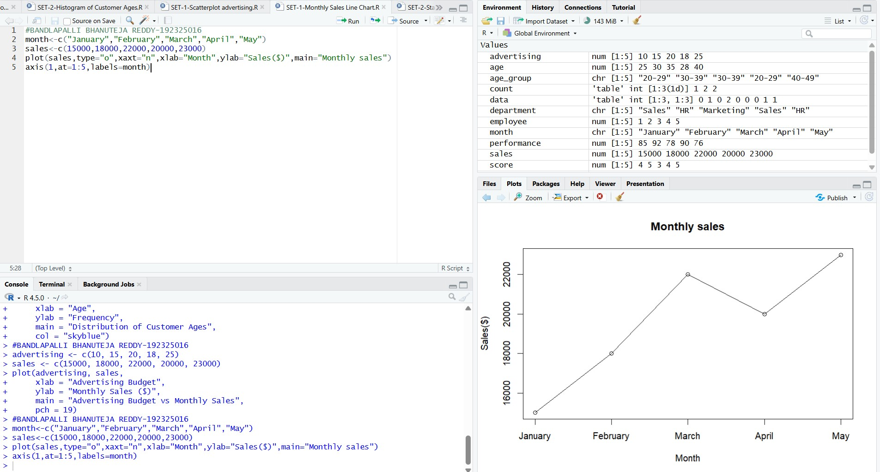

Output 1: Monthly Sales Line Chart
Observation: Sales increase from January to March, decrease slightly in April, and reach the highest value in May.

PROGRAM 2: Bar Chart of Sales
Generate a bar chart to display the sales values for the available months and label the chart elements.
# Dataset month <- c("January", "February", "March", "April", "May") sales <- c(15000, 18000, 22000, 20000, 23000)

# Bar Chart barplot(sales, names.arg = month, xlab = "Month", ylab = "Sales ($)", main = "Monthly Sales", col = "skyblue")

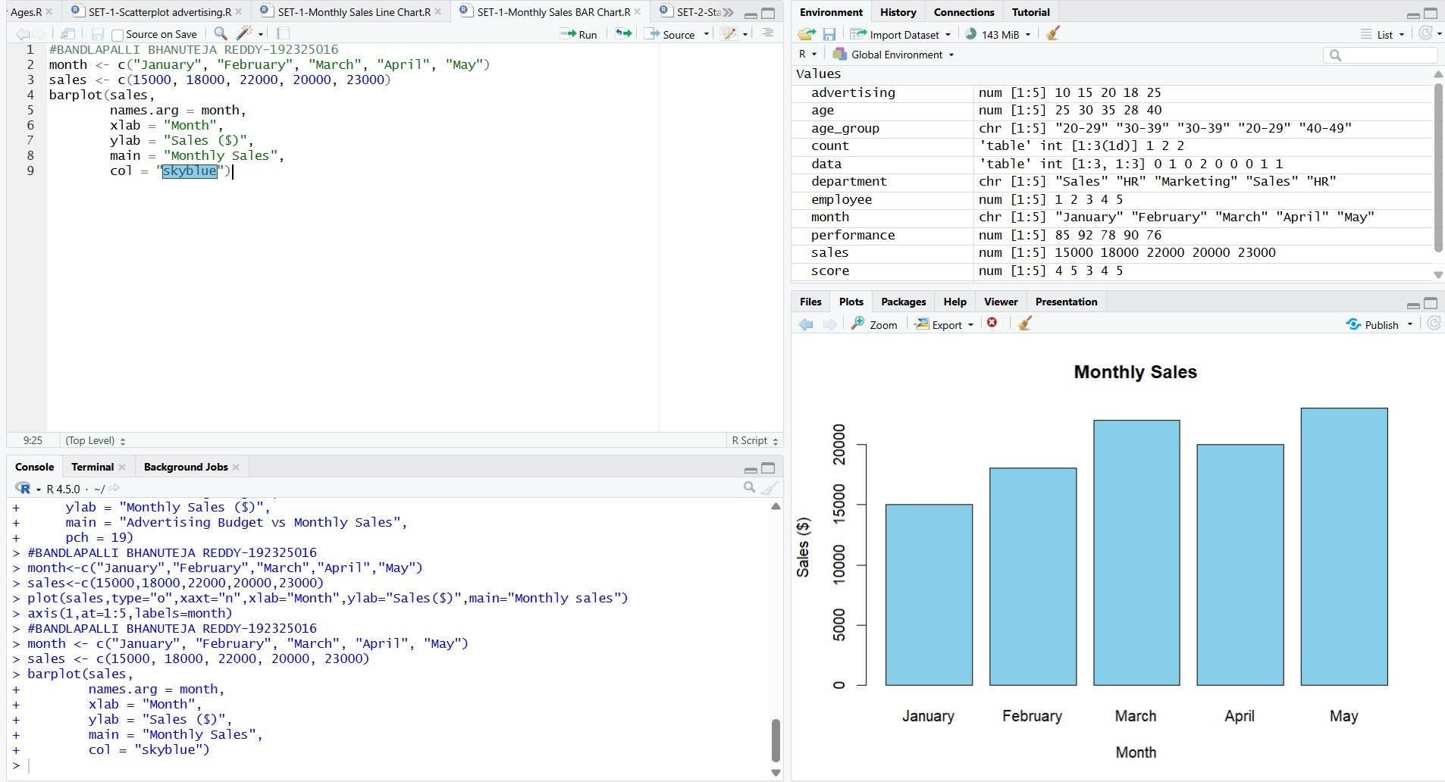

Output 2: Monthly Sales Bar Chart
Observation: The bar chart makes it easy to compare the sales of each month. May has the highest sales and January has the lowest.

PROGRAM 3: Scatter Plot of Advertising Budget vs Monthly Sales
Develop a scatter plot to explore the relationship between advertising budget and monthly sales.
# Dataset sales <- c(15000, 18000, 22000, 20000, 23000)

advertising <- c(5000, 6000, 7000, 8000, 9000)

# Scatter Plot plot(advertising, sales, main = "Advertising Budget vs Monthly Sales", xlab = "Advertising Budget ($)", ylab = "Monthly Sales ($)", pch = 19, col = "red")

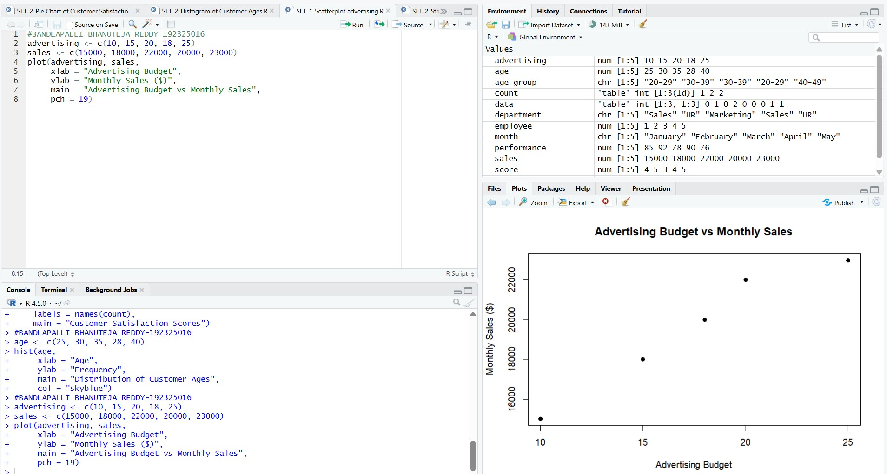

Output 3: Advertising Budget vs Monthly Sales Scatter Plot
Insight: The plotted points show a generally positive relationship: as the advertising budget increases from $5,000 to $9,000, monthly sales also generally increase. This suggests that higher advertising spending is associated with higher sales for the values plotted.
Note: The visible assignment table contains only Month and Sales. The advertising values used in the submitted R program are the five values shown in the user's executed program: 5000, 6000, 7000, 8000, and 9000.

SET 2: CUSTOMER FEEDBACK ANALYSIS

Dataset: Customer Satisfaction
Customer ID | Age | Satisfaction Score
1 | 25 | 4
2 | 30 | 5
3 | 35 | 3
4 | 28 | 4
5 | 40 | 5

PROGRAM 1: Histogram of Customer Ages
Create a histogram to represent the distribution of customer ages. Label the axes and title the chart.
# Dataset age <- c(25, 30, 35, 28, 40)

# Histogram hist(age, main = "Distribution of Customer Ages", xlab = "Age", ylab = "Frequency", col = "skyblue")

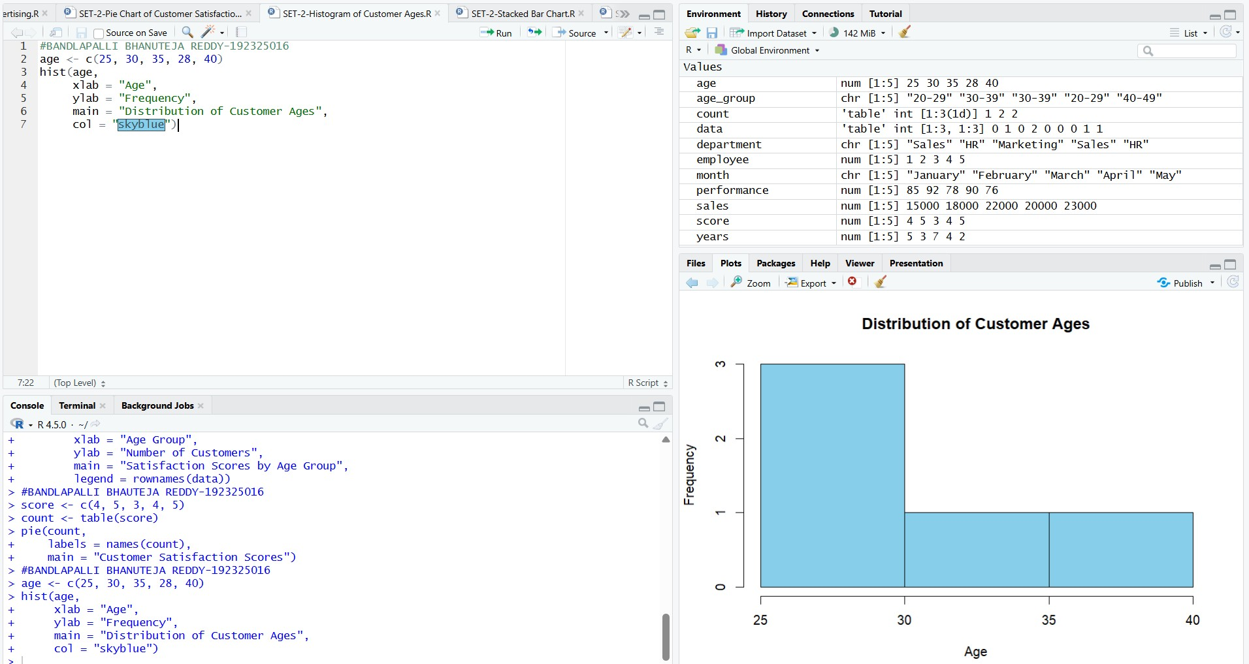

Output 1: Distribution of Customer Ages
Observation: The histogram represents the distribution of the five customer ages in the given dataset.
PROGRAM 2: Pie Chart of Satisfaction Scores
Generate a pie chart to display the overall distribution of customer satisfaction scores and include labels.
# Satisfaction scores satisfaction <- c(4, 5, 3, 4, 5)

# Calculate frequency score_count <- table(satisfaction)

# Pie Chart pie(score_count, labels = paste(names(score_count), "Score"), main = "Customer Satisfaction Scores")

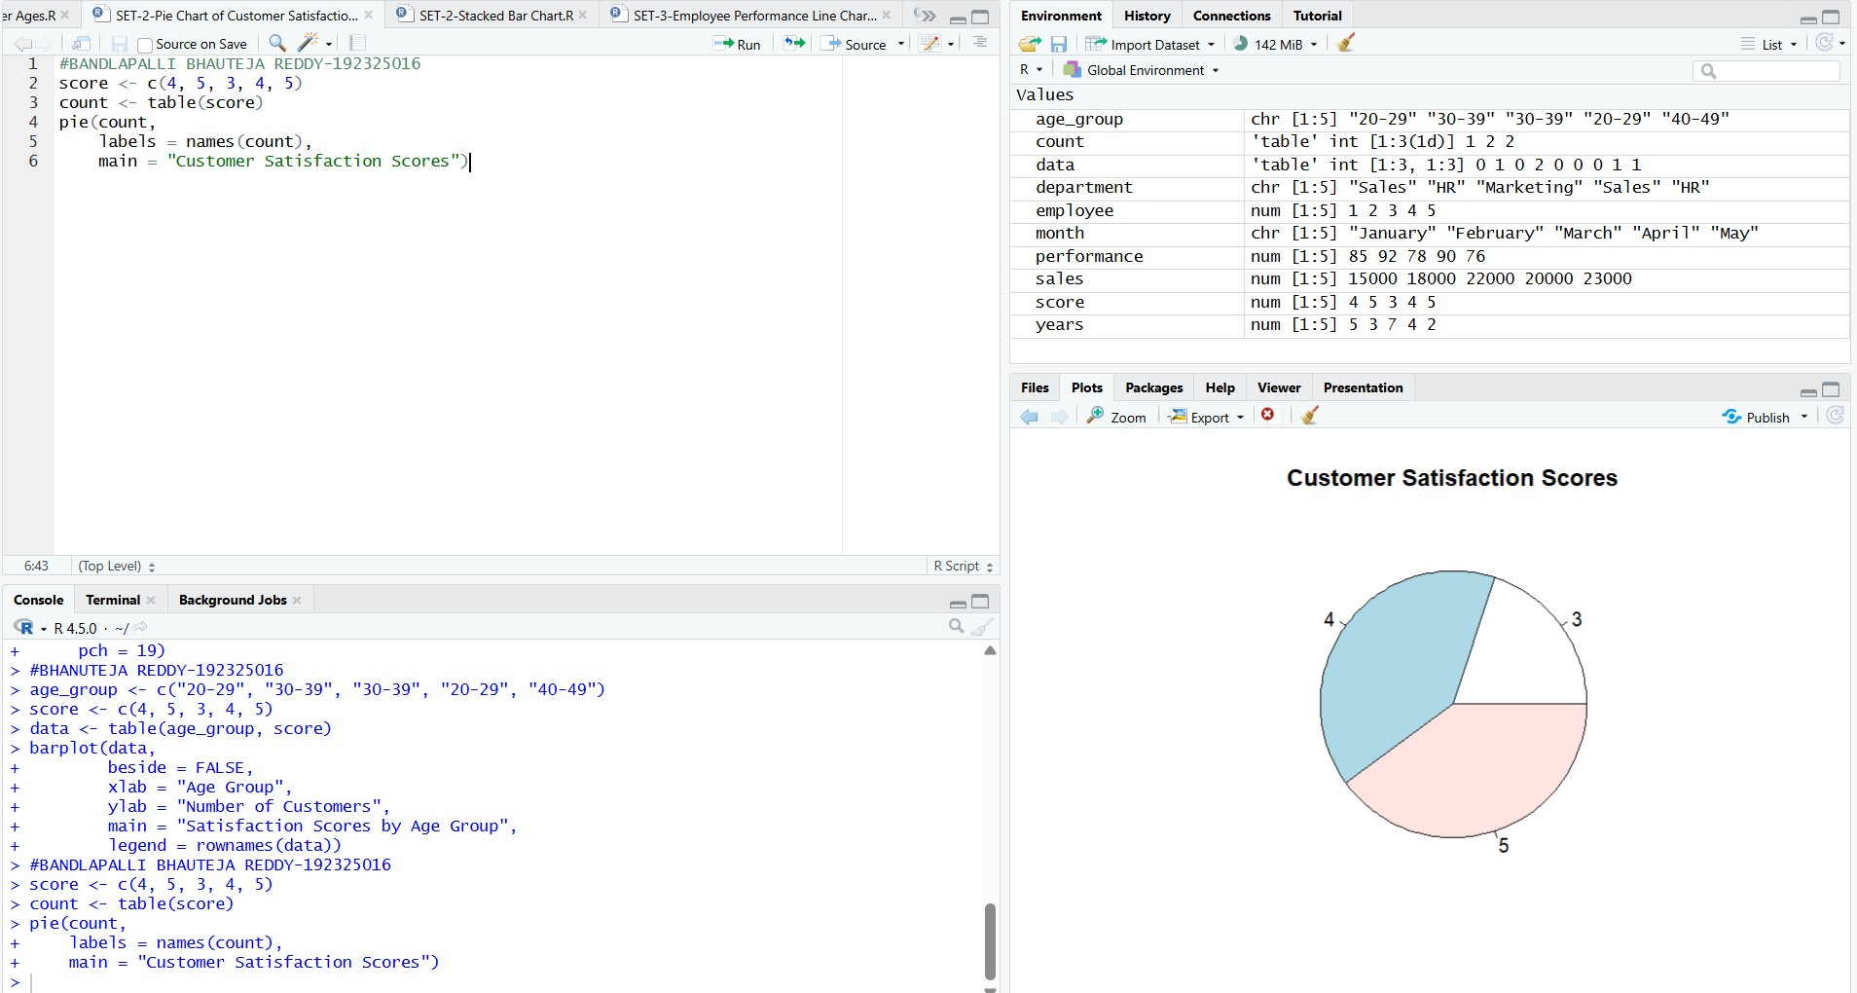

Output 2: Customer Satisfaction Scores Pie Chart
Observation: Scores 4 and 5 each occur twice, while score 3 occurs once.

PROGRAM 3: Stacked Bar Chart by Age Group
Build a stacked bar chart to visualize the distribution of customer satisfaction scores by age group.
# Dataset age <- c(25, 30, 35, 28, 40) satisfaction <- c(4, 5, 3, 4, 5)

# Create age groups age_group <- cut(age,
breaks = c(20, 29, 39, 49), labels = c("20-29", "30-39", "40-49"))

# Create table data <- table(age_group, satisfaction)

# Stacked Bar Chart barplot(data, beside = FALSE, main = "Satisfaction Scores by Age Group", xlab = "Age Group", ylab = "Number of Customers", col = c("skyblue", "lightgreen", "orange"), legend.text = TRUE)

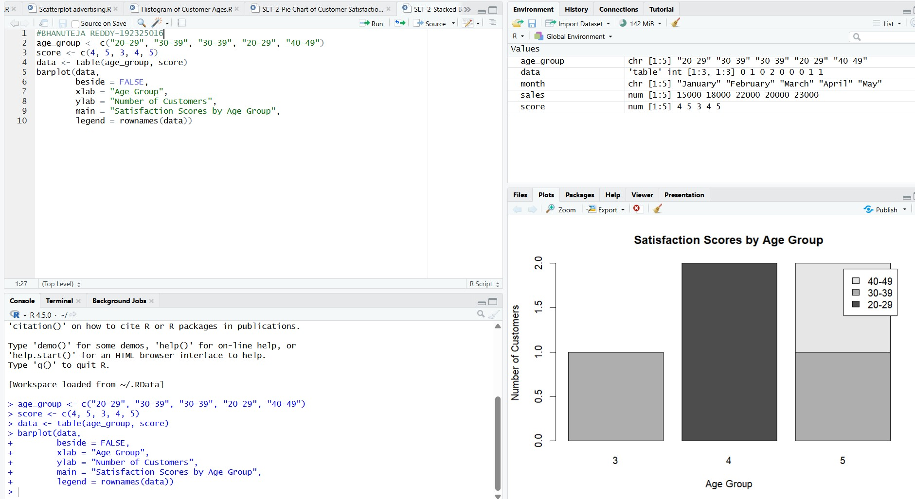

Output 3: Satisfaction Scores by Age Group
Observation: The code creates three age groups and stacks the satisfaction-score frequencies for each group.
Note: The supplied RStudio screenshot is inserted exactly as captured, including its displayed x-axis labels.

SET 3: EMPLOYEE PERFORMANCE EVALUATION

Dataset: Employee Performance
Employee ID | Department | Years of Service | Performance Score
1 | Sales | 5 | 85
2 | HR | 3 | 92
3 | Marketing | 7 | 78
4 | Sales | 4 | 90
5 | HR | 2 | 76

PROGRAM 1: Line Chart of Performance Trend
Create a line chart to visualize the performance trend of employees over time. Include a legend and labels.
# Dataset employee_id <- c(1, 2, 3, 4, 5) performance <- c(85, 92, 78, 90, 76)

# Line Chart plot(employee_id, performance, type = "o", pch = 19, col = "blue", ylim = c(70, 100), xlab = "Employee ID", ylab = "Performance Score", main = "Employee Performance Trend")

# Legend legend("topright", legend = "Performance Score", col = "blue", lty = 1, pch = 19)

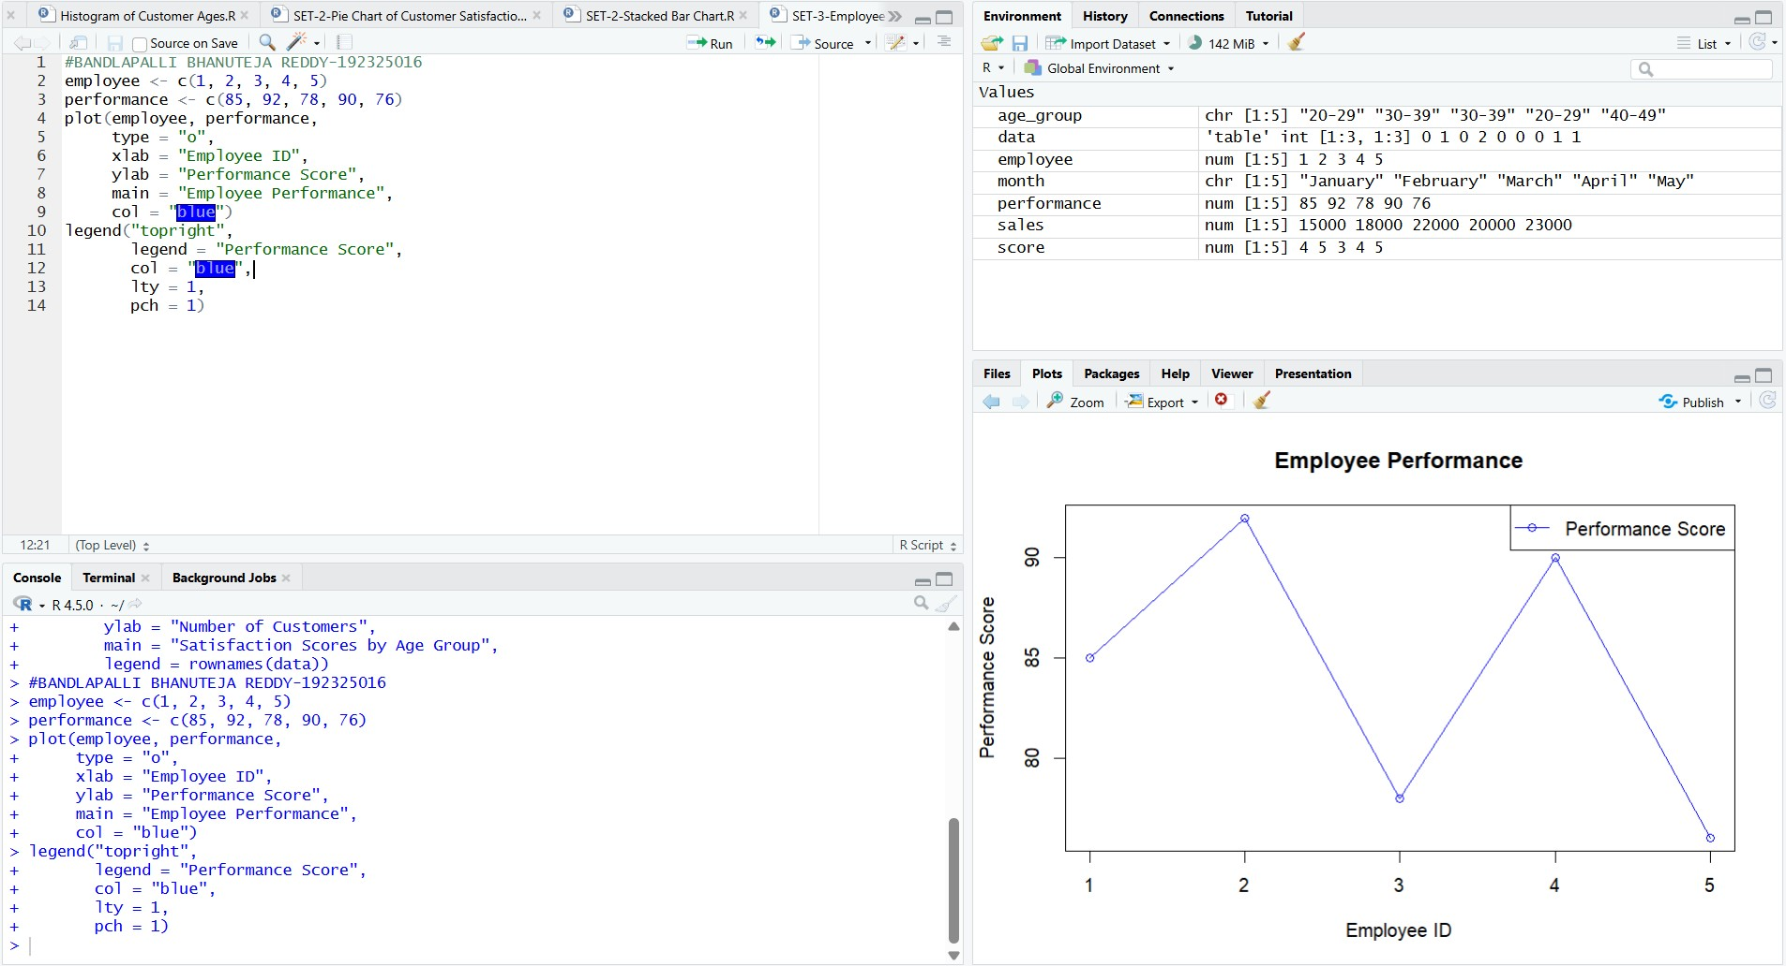

Output 1: Employee Performance Trend
Observation: Performance rises from 85 (Employee 1) to a peak of 92 (Employee 2), falls to 78 for Employee 3, recovers to 90 for Employee 4, and drops to the lowest value of 76 for Employee 5. The legend identifies the plotted series.

PROGRAM 2: Bar Chart of Employees by Department
Generate a bar chart showing the distribution of employees across different departments. Label the chart elements.
# Dataset department <- c("Sales", "HR", "Marketing", "Sales", "HR")

# Count employees in each department dept_count <- table(department)

# Bar Chart barplot(dept_count, xlab = "Department", ylab = "Number of Employees", main = "Employees by Department", col = c("skyblue", "lightgreen", "orange"))

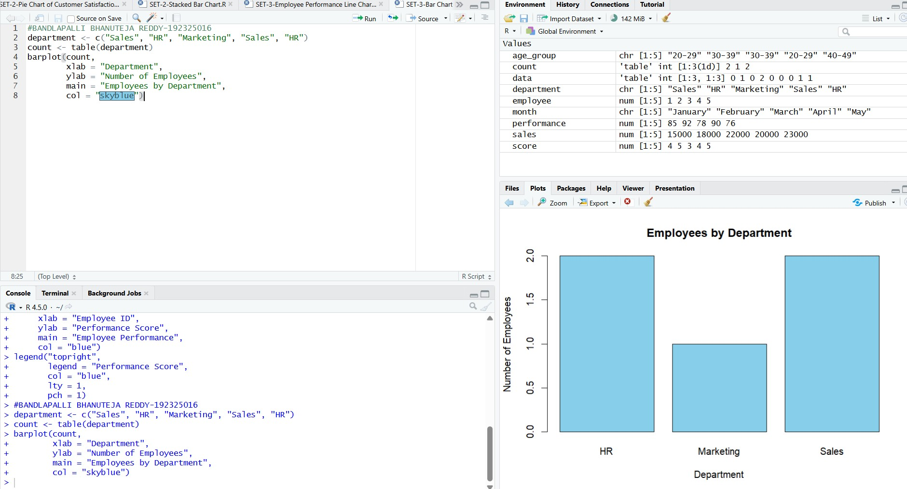

Output 2: Employees by Department
Observation: Sales and HR each have 2 employees, while Marketing has 1 employee. Sales and HR together account for 4 of the 5 employees.

PROGRAM 3: Scatter Plot of Years of Service vs Performance
Build a scatter plot to analyze the correlation between years of service and performance scores. Explain any insights.
# Dataset years <- c(5, 3, 7, 4, 2) performance <- c(85, 92, 78, 90, 76)

# Scatter Plot plot(years, performance, pch = 19, col = "red", xlab = "Years of Service", ylab = "Performance Score", main = "Years of Service vs Performance Score")

# Trend line and correlation abline(lm(performance ~ years), col = "blue") cor(years, performance)

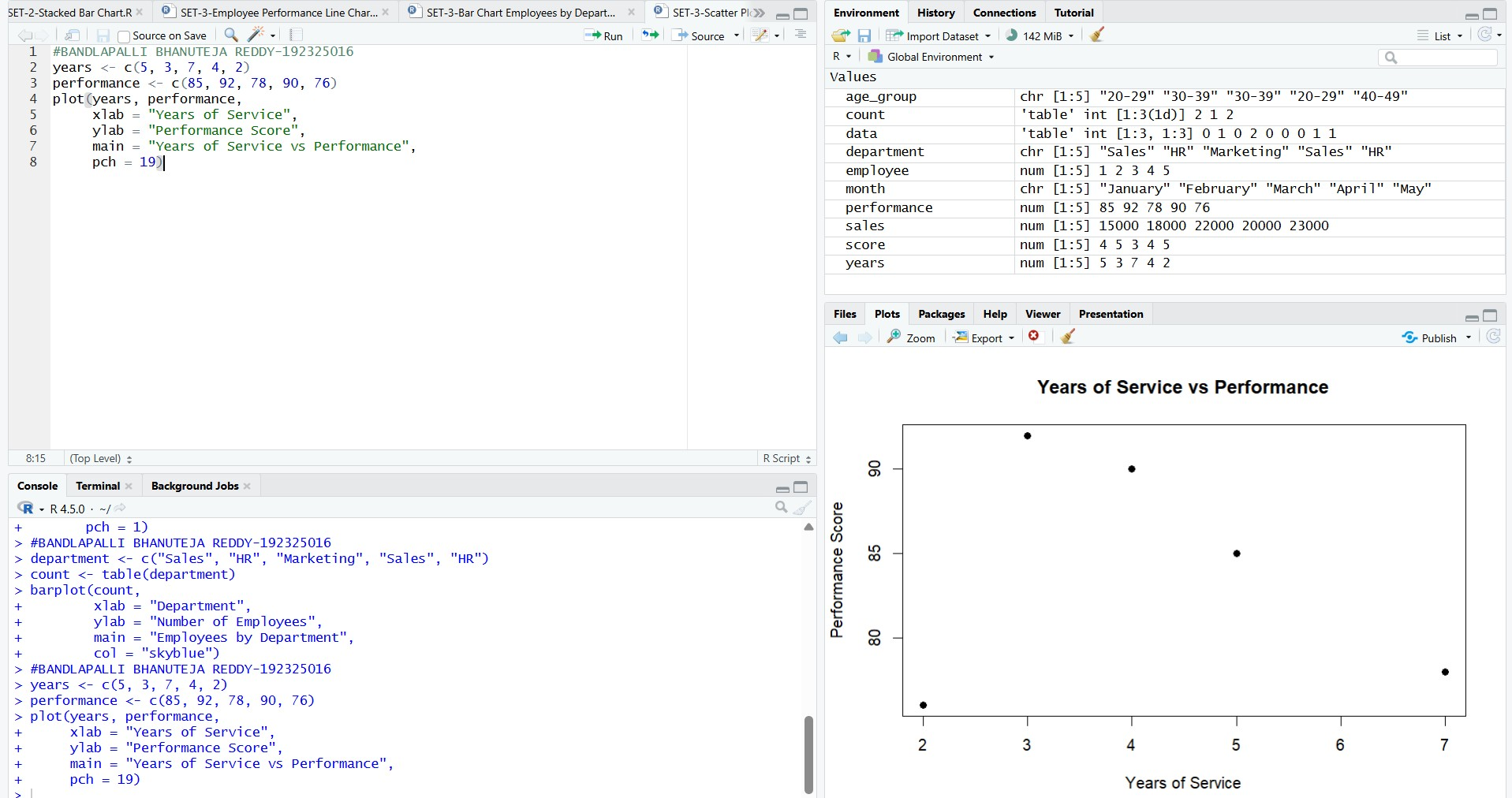

Output 3: Years of Service vs Performance Score
Insight: The correlation coefficient is about -0.17, which indicates a very weak negative relationship. The points are scattered widely around the trend line, so years of service does not clearly predict performance. For example, Employee 3 (7 years) scored 78, while Employee 4 (4 years) scored 90.
Note: Only five records are available, so this result is indicative and should not be generalized.

